Make a Piktochart Infographic in Five Steps
Step 1: Pick a template
- You can scroll through the hundreds of templates according to their respective formats - Infographic, Presentation and Printables (Reports and Posters).
- If you know the name of the theme you are looking for, you can use the search bar.
- You can also filter through themes of similar topics to look for more template options that relate with what you were looking for!
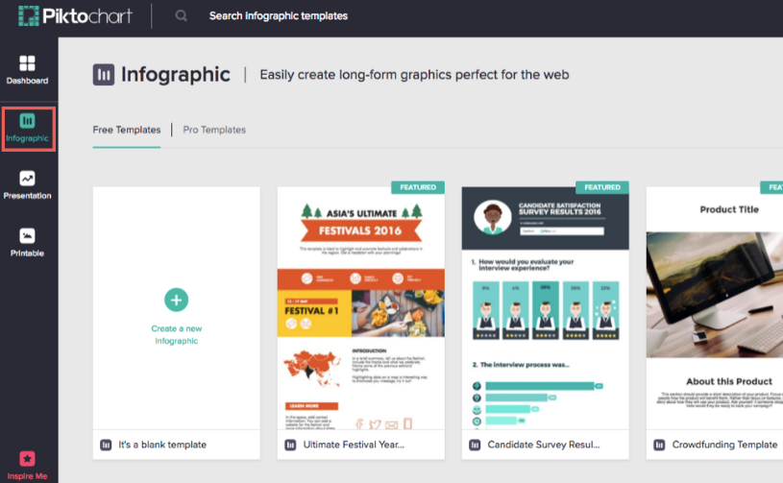

Step 2: Preview or Create
You can first “preview” the template to make sure of your choice, and if so, click “create” to load the selected template. Once you arrive at the editor, you can make edits to text by double-clicking the text box.
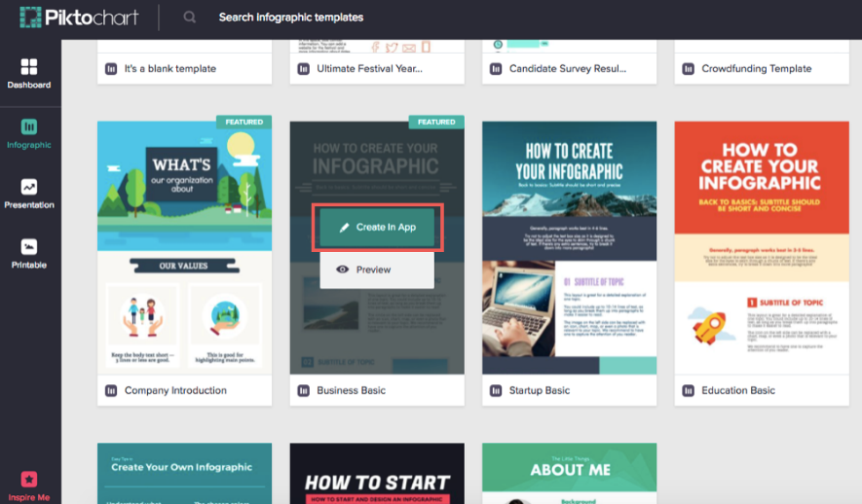

Step 3: Insert graphics
Just click or drag-and-drop the graphics you need from the menu to your canvas. There are thousands of icons and images available in the libraries. Use the search tool or browse through them by categories to make things easier.
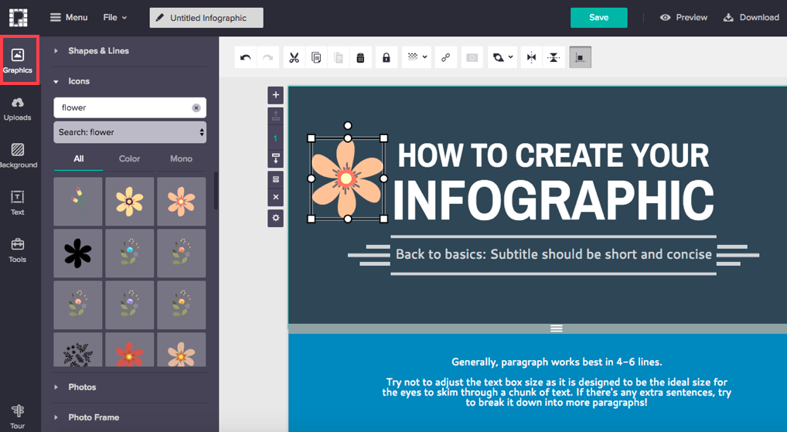
You can also customize how your graphics look by changing the colors, resizing and rotating them.
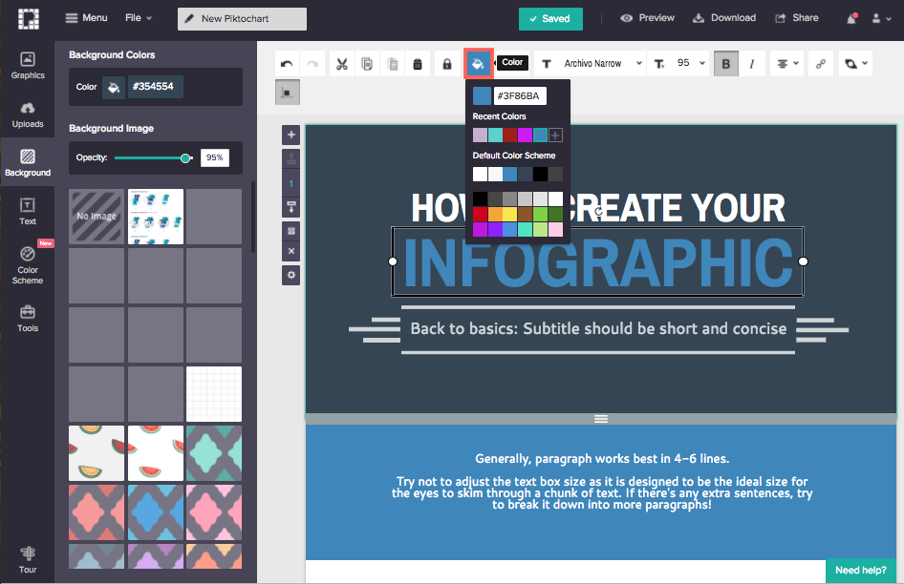

Step 4 : Visualize your data
Use the tools available in the left panel to visualize your data. There are tons of options to create charts and maps that can be customized to beautify your data. A popup will appear from which you can choose the best chart style for your data, coupled with a spreadsheet to input your data.
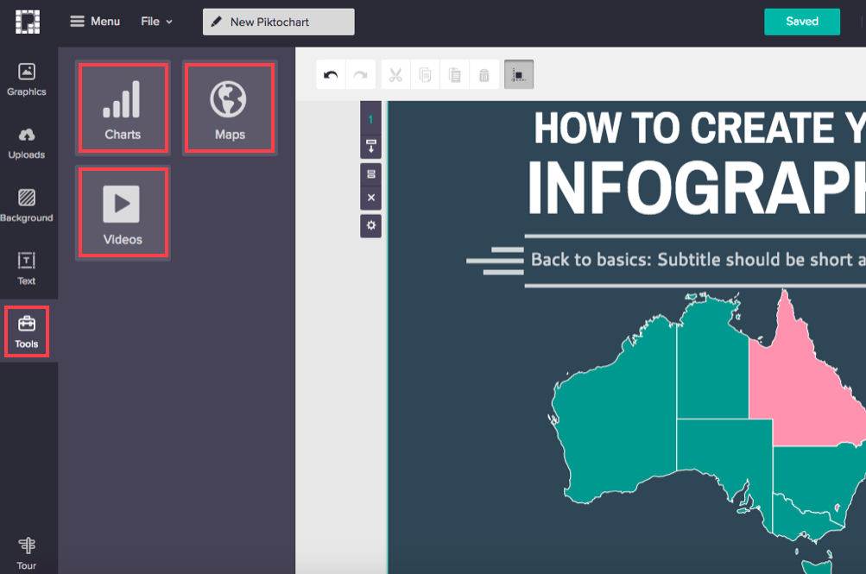

Step 5: Share Your Infographic
You can download your work as an image, publish it online, share by email, or share your infographic directly to social media. View your infographic on the output page by following the provided URL when you publish to the web for public view. Once you have shared it, you and your audience can enjoy your Piktochart in Presentation Mode.
